Epitope mapping and characterization of 4-hydroxy-2-nonenal modified-human serum albumin using two different polyclonal antibodies
Isabel Campos-Pinto*^{1, 2}, Lucía Méndez^{3,4,5}, James Schouten¹, John Wilkins¹, Maria Fedorova^{3,4}, Andrew Pitt², Paul Davis¹, Corinne Spickett²
Free Radical Biology and Medicine

Campos-Pinto et al. Supplementary data
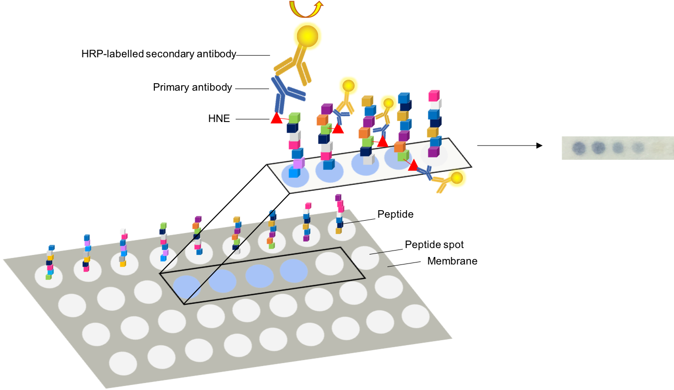

Supplementary Fig. 1. Schematic representation of the peptide array. The membrane is firstly incubated with HNE and subsequently with the primary and the HRP-labelled secondary antibody. After incubation with the substrate, the peptide spots to which the antibody is bound develop a blue colour.

Supplementary Fig. 2. Screening of the antibodies present in the pre-immune bleed and in four post-immunization bleeds collected from a sheep immunized with HNE-modified HSA. The binding to HNE modified Ovalbumin (OVA) was accessed by ELISA assay.

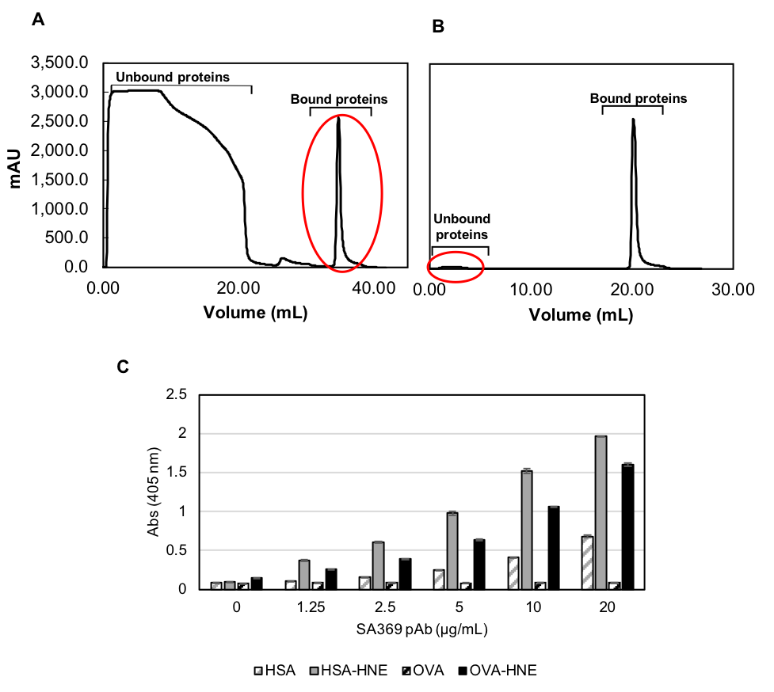

Supplementary Fig. 3. SA369 anti-HSA-HNE pAb enriched pAb purification chromatograms from affinity purification using an HSA-HNE-coupled resin to recover the mixture of anti-HA and anti-HSA-HNE IgGs (A) and an HSA-coupled resin for depletion of anti-HSA antibodies (B). The bound pooled fraction of the antibodies obtained in (A) (circled in red) were loading into the second column, where the enriched pooled fraction of anti-HAS-HNE was collected from the unbound fraction (circled in red). Binding assessment of the enriched pAbs to HSA, HSA-HNE, OVA and OVA-HNE by direct ELISA was performed by immobilizing the antigens at 1.25 μg/mL and testing with the antibody con.centrations indicated on the graph. Average of 3 technical replicate ± SEM.

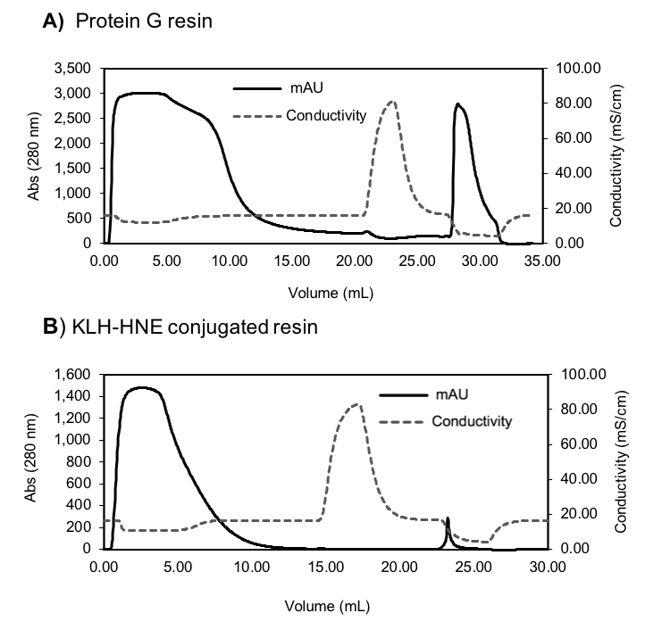
Supplementary Fig. 4. Chromatogram obtained from the purification of the IgGs from the crude sheep sera (SA369) with a protein G resin (A) and from the enrichment of anti-HNE antibodies using a KLH-HNE conjugated resin (B).

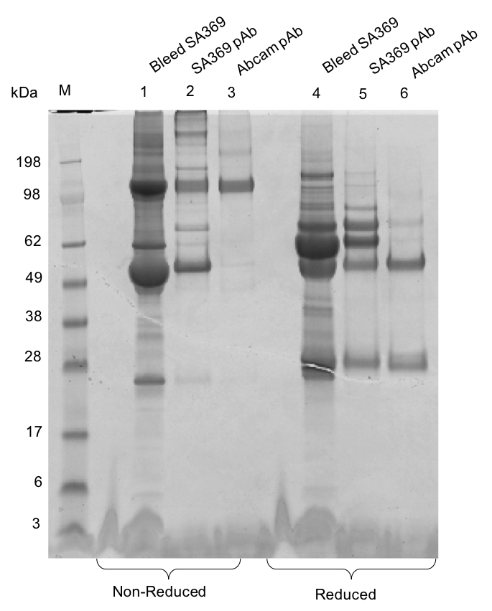

Supplementary Figure 5. Purification of SA369 pAbs from the sheep bleed SA369 using a KLH-HNE covalently bound to a sepharose resin. The collected pooled fractions contain still a trace of serum albumin as observed by a band corresponding to the weight of 65 kDa and some other immunoglobulins of higher molecular weight, possibly IgM. Samples in lanes 1, 2 and 3 were run under non-reducing conditions, while samples in lanes 4, 5 and 6 were run under reducing conditions. ﻿In lanes 5 and 6 bands corresponding to the weight of the heavy (50 kDa) and light chains (25 kDa) of the pAbs are seen. Proteins were separated by SDS- PAGE and stained by Coomassie blue.

Supplementary Figure 6. ELISA assay comparing the binding of the anti-HNE Abcam and the Anti-HSA-HNE SA369 antibodies to recombinant HSA expressed in Saccharomyces cerevisiae and standard HSA (the same HSA molecule used for immunization).
Supplementary Table 1. List of the human serum albumin (UniProt ID: P02768) peptides synthesized on the arrays. The sequence includes both the signal peptide (1-18) and pro-peptide (19-24) of HSA.
Positional Reference | Peptide sequence | Positional Reference | Peptide sequence
A1 | Blank | B26 | G-E-M-A-D-C-C-A-K-Q-E-P-E-R-N
A2 | M-K-W-V-T-F-I-S-L-L-F-L-F-S-S | B27 | M-A-D-C-C-A-K-Q-E-P-E-R-N-E-C
A3 | W-V-T-F-I-S-L-L-F-L-F-S-S-A-Y | B28 | D-C-C-A-K-Q-E-P-E-R-N-E-C-F-L
A4 | T-F-I-S-L-L-F-L-F-S-S-A-Y-S-R | B29 | C-A-K-Q-E-P-E-R-N-E-C-F-L-Q-H
A5 | I-S-L-L-F-L-F-S-S-A-Y-S-R-G-V | B30 | K-Q-E-P-E-R-N-E-C-F-L-Q-H-K-D
A6 | L-L-F-L-F-S-S-A-Y-S-R-G-V-F-R | C1 | E-P-E-R-N-E-C-F-L-Q-H-K-D-D-N
A7 | F-L-F-S-S-A-Y-S-R-G-V-F-R-R-D | C2 | E-R-N-E-C-F-L-Q-H-K-D-D-N-P-N
A8 | F-S-S-A-Y-S-R-G-V-F-R-R-D-A-H | C3 | N-E-C-F-L-Q-H-K-D-D-N-P-N-L-P
A9 | S-A-Y-S-R-G-V-F-R-R-D-A-H-K-S | C4 | C-F-L-Q-H-K-D-D-N-P-N-L-P-R-L
A10 | Y-S-R-G-V-F-R-R-D-A-H-K-S-E-V | C5 | L-Q-H-K-D-D-N-P-N-L-P-R-L-V-R
A11 | R-G-V-F-R-R-D-A-H-K-S-E-V-A-H | C6 | H-K-D-D-N-P-N-L-P-R-L-V-R-P-E
A12 | V-F-R-R-D-A-H-K-S-E-V-A-H-R-F | C7 | D-D-N-P-N-L-P-R-L-V-R-P-E-V-D
A13 | R-R-D-A-H-K-S-E-V-A-H-R-F-K-D | C8 | N-P-N-L-P-R-L-V-R-P-E-V-D-V-M
A14 | D-A-H-K-S-E-V-A-H-R-F-K-D-L-G | C9 | N-L-P-R-L-V-R-P-E-V-D-V-M-C-T
A15 | H-K-S-E-V-A-H-R-F-K-D-L-G-E-E | C10 | P-R-L-V-R-P-E-V-D-V-M-C-T-A-F
A16 | S-E-V-A-H-R-F-K-D-L-G-E-E-N-F | C11 | L-V-R-P-E-V-D-V-M-C-T-A-F-H-D
A17 | V-A-H-R-F-K-D-L-G-E-E-N-F-K-A | C12 | R-P-E-V-D-V-M-C-T-A-F-H-D-N-E
A18 | H-R-F-K-D-L-G-E-E-N-F-K-A-L-V | C13 | E-V-D-V-M-C-T-A-F-H-D-N-E-E-T
A19 | F-K-D-L-G-E-E-N-F-K-A-L-V-L-I | C14 | D-V-M-C-T-A-F-H-D-N-E-E-T-F-L
A20 | D-L-G-E-E-N-F-K-A-L-V-L-I-A-F | C15 | M-C-T-A-F-H-D-N-E-E-T-F-L-K-K
A21 | G-E-E-N-F-K-A-L-V-L-I-A-F-A-Q | C16 | T-A-F-H-D-N-E-E-T-F-L-K-K-Y-L
A22 | E-N-F-K-A-L-V-L-I-A-F-A-Q-Y-L | C17 | F-H-D-N-E-E-T-F-L-K-K-Y-L-Y-E
A23 | F-K-A-L-V-L-I-A-F-A-Q-Y-L-Q-Q | C18 | D-N-E-E-T-F-L-K-K-Y-L-Y-E-I-A
A24 | A-L-V-L-I-A-F-A-Q-Y-L-Q-Q-C-P | C19 | E-E-T-F-L-K-K-Y-L-Y-E-I-A-R-R
A25 | V-L-I-A-F-A-Q-Y-L-Q-Q-C-P-F-E | C20 | T-F-L-K-K-Y-L-Y-E-I-A-R-R-H-P
A26 | I-A-F-A-Q-Y-L-Q-Q-C-P-F-E-D-H | C21 | L-K-K-Y-L-Y-E-I-A-R-R-H-P-Y-F
A27 | F-A-Q-Y-L-Q-Q-C-P-F-E-D-H-V-K | C22 | K-Y-L-Y-E-I-A-R-R-H-P-Y-F-Y-A
A28 | Q-Y-L-Q-Q-C-P-F-E-D-H-V-K-L-V | C23 | L-Y-E-I-A-R-R-H-P-Y-F-Y-A-P-E
A29 | L-Q-Q-C-P-F-E-D-H-V-K-L-V-N-E | C24 | E-I-A-R-R-H-P-Y-F-Y-A-P-E-L-L
A30 | Q-C-P-F-E-D-H-V-K-L-V-N-E-V-T | C25 | A-R-R-H-P-Y-F-Y-A-P-E-L-L-F-F
B1 | P-F-E-D-H-V-K-L-V-N-E-V-T-E-F | C26 | R-H-P-Y-F-Y-A-P-E-L-L-F-F-A-K
B2 | E-D-H-V-K-L-V-N-E-V-T-E-F-A-K | C27 | P-Y-F-Y-A-P-E-L-L-F-F-A-K-R-Y
B3 | H-V-K-L-V-N-E-V-T-E-F-A-K-T-C | C28 | F-Y-A-P-E-L-L-F-F-A-K-R-Y-K-A
B4 | K-L-V-N-E-V-T-E-F-A-K-T-C-V-A | C29 | A-P-E-L-L-F-F-A-K-R-Y-K-A-A-F
B5 | V-N-E-V-T-E-F-A-K-T-C-V-A-D-E | C30 | E-L-L-F-F-A-K-R-Y-K-A-A-F-T-E
B6 | E-V-T-E-F-A-K-T-C-V-A-D-E-S-A | D1 | L-F-F-A-K-R-Y-K-A-A-F-T-E-C-C
B7 | T-E-F-A-K-T-C-V-A-D-E-S-A-E-N | D2 | F-A-K-R-Y-K-A-A-F-T-E-C-C-Q-A
B8 | F-A-K-T-C-V-A-D-E-S-A-E-N-C-D | D3 | K-R-Y-K-A-A-F-T-E-C-C-Q-A-A-D
B9 | K-T-C-V-A-D-E-S-A-E-N-C-D-K-S | D4 | Y-K-A-A-F-T-E-C-C-Q-A-A-D-K-A
B10 | C-V-A-D-E-S-A-E-N-C-D-K-S-L-H | D5 | A-A-F-T-E-C-C-Q-A-A-D-K-A-A-C
B11 | A-D-E-S-A-E-N-C-D-K-S-L-H-T-L | D6 | F-T-E-C-C-Q-A-A-D-K-A-A-C-L-L
B12 | E-S-A-E-N-C-D-K-S-L-H-T-L-F-G | D7 | E-C-C-Q-A-A-D-K-A-A-C-L-L-P-K
B13 | A-E-N-C-D-K-S-L-H-T-L-F-G-D-K | D8 | C-Q-A-A-D-K-A-A-C-L-L-P-K-L-D
B14 | N-C-D-K-S-L-H-T-L-F-G-D-K-L-C | D9 | A-A-D-K-A-A-C-L-L-P-K-L-D-E-L
B15 | D-K-S-L-H-T-L-F-G-D-K-L-C-T-V | D10 | D-K-A-A-C-L-L-P-K-L-D-E-L-R-D
B16 | S-L-H-T-L-F-G-D-K-L-C-T-V-A-T | D11 | A-A-C-L-L-P-K-L-D-E-L-R-D-E-G
B17 | H-T-L-F-G-D-K-L-C-T-V-A-T-L-R | D12 | C-L-L-P-K-L-D-E-L-R-D-E-G-K-A
B18 | L-F-G-D-K-L-C-T-V-A-T-L-R-E-T | D13 | L-P-K-L-D-E-L-R-D-E-G-K-A-S-S
B19 | G-D-K-L-C-T-V-A-T-L-R-E-T-Y-G | D14 | K-L-D-E-L-R-D-E-G-K-A-S-S-A-K
B20 | K-L-C-T-V-A-T-L-R-E-T-Y-G-E-M | D15 | D-E-L-R-D-E-G-K-A-S-S-A-K-Q-R
B21 | C-T-V-A-T-L-R-E-T-Y-G-E-M-A-D | D16 | L-R-D-E-G-K-A-S-S-A-K-Q-R-L-K
B22 | V-A-T-L-R-E-T-Y-G-E-M-A-D-C-C | D17 | D-E-G-K-A-S-S-A-K-Q-R-L-K-C-A
B23 | T-L-R-E-T-Y-G-E-M-A-D-C-C-A-K | D18 | G-K-A-S-S-A-K-Q-R-L-K-C-A-S-L
B24 | R-E-T-Y-G-E-M-A-D-C-C-A-K-Q-E | D19 | A-S-S-A-K-Q-R-L-K-C-A-S-L-Q-K
B25 | T-Y-G-E-M-A-D-C-C-A-K-Q-E-P-E | D20 | S-A-K-Q-R-L-K-C-A-S-L-Q-K-F-G

Positional Reference | Peptide sequence | Positional Reference | Peptide sequence
D21 | K-Q-R-L-K-C-A-S-L-Q-K-F-G-E-R | F16 | L-A-A-D-F-V-E-S-K-D-V-C-K-N-Y
D22 | R-L-K-C-A-S-L-Q-K-F-G-E-R-A-F | F17 | A-D-F-V-E-S-K-D-V-C-K-N-Y-A-E
D23 | K-C-A-S-L-Q-K-F-G-E-R-A-F-K-A | F18 | F-V-E-S-K-D-V-C-K-N-Y-A-E-A-K
D24 | A-S-L-Q-K-F-G-E-R-A-F-K-A-W-A | F19 | E-S-K-D-V-C-K-N-Y-A-E-A-K-D-V
D25 | L-Q-K-F-G-E-R-A-F-K-A-W-A-V-A | F20 | K-D-V-C-K-N-Y-A-E-A-K-D-V-F-L
D26 | K-F-G-E-R-A-F-K-A-W-A-V-A-R-L | F21 | V-C-K-N-Y-A-E-A-K-D-V-F-L-G-M
D27 | G-E-R-A-F-K-A-W-A-V-A-R-L-S-Q | F22 | K-N-Y-A-E-A-K-D-V-F-L-G-M-F-L
D28 | R-A-F-K-A-W-A-V-A-R-L-S-Q-R-F | F23 | Y-A-E-A-K-D-V-F-L-G-M-F-L-Y-E
D29 | F-K-A-W-A-V-A-R-L-S-Q-R-F-P-K | F24 | E-A-K-D-V-F-L-G-M-F-L-Y-E-Y-A
D30 | A-W-A-V-A-R-L-S-Q-R-F-P-K-A-E | F25 | K-D-V-F-L-G-M-F-L-Y-E-Y-A-R-R
E1 | A-V-A-R-L-S-Q-R-F-P-K-A-E-F-A | F26 | V-F-L-G-M-F-L-Y-E-Y-A-R-R-H-P
E2 | A-R-L-S-Q-R-F-P-K-A-E-F-A-E-V | F27 | L-G-M-F-L-Y-E-Y-A-R-R-H-P-D-Y
E3 | L-S-Q-R-F-P-K-A-E-F-A-E-V-S-K | F28 | M-F-L-Y-E-Y-A-R-R-H-P-D-Y-S-V
E4 | Q-R-F-P-K-A-E-F-A-E-V-S-K-L-V | F29 | L-Y-E-Y-A-R-R-H-P-D-Y-S-V-V-L
E5 | F-P-K-A-E-F-A-E-V-S-K-L-V-T-D | F30 | E-Y-A-R-R-H-P-D-Y-S-V-V-L-L-L
E6 | K-A-E-F-A-E-V-S-K-L-V-T-D-L-T | G1 | A-R-R-H-P-D-Y-S-V-V-L-L-L-R-L
E7 | E-F-A-E-V-S-K-L-V-T-D-L-T-K-V | G2 | R-H-P-D-Y-S-V-V-L-L-L-R-L-A-K
E8 | A-E-V-S-K-L-V-T-D-L-T-K-V-H-T | G3 | P-D-Y-S-V-V-L-L-L-R-L-A-K-T-Y
E9 | V-S-K-L-V-T-D-L-T-K-V-H-T-E-C | G4 | Y-S-V-V-L-L-L-R-L-A-K-T-Y-E-T
E10 | K-L-V-T-D-L-T-K-V-H-T-E-C-C-H | G5 | V-V-L-L-L-R-L-A-K-T-Y-E-T-T-L
E11 | V-T-D-L-T-K-V-H-T-E-C-C-H-G-D | G6 | L-L-L-R-L-A-K-T-Y-E-T-T-L-E-K
E12 | D-L-T-K-V-H-T-E-C-C-H-G-D-L-L | G7 | L-R-L-A-K-T-Y-E-T-T-L-E-K-C-C
E13 | T-K-V-H-T-E-C-C-H-G-D-L-L-E-C | G8 | L-A-K-T-Y-E-T-T-L-E-K-C-C-A-A
E14 | V-H-T-E-C-C-H-G-D-L-L-E-C-A-D | G9 | K-T-Y-E-T-T-L-E-K-C-C-A-A-A-D
E15 | T-E-C-C-H-G-D-L-L-E-C-A-D-D-R | G10 | Y-E-T-T-L-E-K-C-C-A-A-A-D-P-H
E16 | C-C-H-G-D-L-L-E-C-A-D-D-R-A-D | G11 | T-T-L-E-K-C-C-A-A-A-D-P-H-E-C
E17 | H-G-D-L-L-E-C-A-D-D-R-A-D-L-A | G12 | L-E-K-C-C-A-A-A-D-P-H-E-C-Y-A
E18 | D-L-L-E-C-A-D-D-R-A-D-L-A-K-Y | G13 | K-C-C-A-A-A-D-P-H-E-C-Y-A-K-V
E19 | L-E-C-A-D-D-R-A-D-L-A-K-Y-I-C | G14 | C-A-A-A-D-P-H-E-C-Y-A-K-V-F-D
E20 | C-A-D-D-R-A-D-L-A-K-Y-I-C-E-N | G15 | A-A-D-P-H-E-C-Y-A-K-V-F-D-E-F
E21 | D-D-R-A-D-L-A-K-Y-I-C-E-N-Q-D | G16 | D-P-H-E-C-Y-A-K-V-F-D-E-F-K-P
E22 | R-A-D-L-A-K-Y-I-C-E-N-Q-D-S-I | G17 | H-E-C-Y-A-K-V-F-D-E-F-K-P-L-V
E23 | D-L-A-K-Y-I-C-E-N-Q-D-S-I-S-S | G18 | C-Y-A-K-V-F-D-E-F-K-P-L-V-E-E
E24 | A-K-Y-I-C-E-N-Q-D-S-I-S-S-K-L | G19 | A-K-V-F-D-E-F-K-P-L-V-E-E-P-Q
E25 | Y-I-C-E-N-Q-D-S-I-S-S-K-L-K-E | G20 | V-F-D-E-F-K-P-L-V-E-E-P-Q-N-L
E26 | C-E-N-Q-D-S-I-S-S-K-L-K-E-C-C | G21 | D-E-F-K-P-L-V-E-E-P-Q-N-L-I-K
E27 | N-Q-D-S-I-S-S-K-L-K-E-C-C-E-K | G22 | F-K-P-L-V-E-E-P-Q-N-L-I-K-Q-N
E28 | D-S-I-S-S-K-L-K-E-C-C-E-K-P-L | G23 | P-L-V-E-E-P-Q-N-L-I-K-Q-N-C-E
E29 | I-S-S-K-L-K-E-C-C-E-K-P-L-L-E | G24 | V-E-E-P-Q-N-L-I-K-Q-N-C-E-L-F
E30 | S-K-L-K-E-C-C-E-K-P-L-L-E-K-S | G25 | E-P-Q-N-L-I-K-Q-N-C-E-L-F-E-Q
F1 | L-K-E-C-C-E-K-P-L-L-E-K-S-H-C | G26 | Q-N-L-I-K-Q-N-C-E-L-F-E-Q-L-G
F2 | E-C-C-E-K-P-L-L-E-K-S-H-C-I-A | G27 | L-I-K-Q-N-C-E-L-F-E-Q-L-G-E-Y
F3 | C-E-K-P-L-L-E-K-S-H-C-I-A-E-V | G28 | K-Q-N-C-E-L-F-E-Q-L-G-E-Y-K-F
F4 | K-P-L-L-E-K-S-H-C-I-A-E-V-E-N | G29 | N-C-E-L-F-E-Q-L-G-E-Y-K-F-Q-N
F5 | L-L-E-K-S-H-C-I-A-E-V-E-N-D-E | G30 | E-L-F-E-Q-L-G-E-Y-K-F-Q-N-A-L
F6 | E-K-S-H-C-I-A-E-V-E-N-D-E-M-P | H1 | F-E-Q-L-G-E-Y-K-F-Q-N-A-L-L-V
F7 | S-H-C-I-A-E-V-E-N-D-E-M-P-A-D | H2 | Q-L-G-E-Y-K-F-Q-N-A-L-L-V-R-Y
F8 | C-I-A-E-V-E-N-D-E-M-P-A-D-L-P | H3 | G-E-Y-K-F-Q-N-A-L-L-V-R-Y-T-K
F9 | A-E-V-E-N-D-E-M-P-A-D-L-P-S-L | H4 | Y-K-F-Q-N-A-L-L-V-R-Y-T-K-K-V
F10 | V-E-N-D-E-M-P-A-D-L-P-S-L-A-A | H5 | F-Q-N-A-L-L-V-R-Y-T-K-K-V-P-Q
F11 | N-D-E-M-P-A-D-L-P-S-L-A-A-D-F | H6 | N-A-L-L-V-R-Y-T-K-K-V-P-Q-V-S
F12 | E-M-P-A-D-L-P-S-L-A-A-D-F-V-E | H7 | L-L-V-R-Y-T-K-K-V-P-Q-V-S-T-P
F13 | P-A-D-L-P-S-L-A-A-D-F-V-E-S-K | H8 | V-R-Y-T-K-K-V-P-Q-V-S-T-P-T-L
F14 | D-L-P-S-L-A-A-D-F-V-E-S-K-D-V | H9 | Y-T-K-K-V-P-Q-V-S-T-P-T-L-V-E
F15 | P-S-L-A-A-D-F-V-E-S-K-D-V-C-K | H10 | K-K-V-P-Q-V-S-T-P-T-L-V-E-V-S

Positional Reference | Peptide sequence | Positional Reference | Peptide sequence
H11 | V-P-Q-V-S-T-P-T-L-V-E-V-S-R-N | J6 | K-Q-T-A-L-V-E-L-V-K-H-K-P-K-A
H12 | Q-V-S-T-P-T-L-V-E-V-S-R-N-L-G | J7 | T-A-L-V-E-L-V-K-H-K-P-K-A-T-K
H13 | S-T-P-T-L-V-E-V-S-R-N-L-G-K-V | J8 | L-V-E-L-V-K-H-K-P-K-A-T-K-E-Q
H14 | P-T-L-V-E-V-S-R-N-L-G-K-V-G-S | J9 | E-L-V-K-H-K-P-K-A-T-K-E-Q-L-K
H15 | L-V-E-V-S-R-N-L-G-K-V-G-S-K-C | J10 | V-K-H-K-P-K-A-T-K-E-Q-L-K-A-V
H16 | E-V-S-R-N-L-G-K-V-G-S-K-C-C-K | J11 | H-K-P-K-A-T-K-E-Q-L-K-A-V-M-D
H17 | S-R-N-L-G-K-V-G-S-K-C-C-K-H-P | J12 | P-K-A-T-K-E-Q-L-K-A-V-M-D-D-F
H18 | N-L-G-K-V-G-S-K-C-C-K-H-P-E-A | J13 | A-T-K-E-Q-L-K-A-V-M-D-D-F-A-A
H19 | G-K-V-G-S-K-C-C-K-H-P-E-A-K-R | J14 | K-E-Q-L-K-A-V-M-D-D-F-A-A-F-V
H20 | V-G-S-K-C-C-K-H-P-E-A-K-R-M-P | J15 | Q-L-K-A-V-M-D-D-F-A-A-F-V-E-K
H21 | S-K-C-C-K-H-P-E-A-K-R-M-P-C-A | J16 | K-A-V-M-D-D-F-A-A-F-V-E-K-C-C
H22 | C-C-K-H-P-E-A-K-R-M-P-C-A-E-D | J17 | V-M-D-D-F-A-A-F-V-E-K-C-C-K-A
H23 | K-H-P-E-A-K-R-M-P-C-A-E-D-Y-L | J18 | D-D-F-A-A-F-V-E-K-C-C-K-A-D-D
H24 | P-E-A-K-R-M-P-C-A-E-D-Y-L-S-V | J19 | F-A-A-F-V-E-K-C-C-K-A-D-D-K-E
H25 | A-K-R-M-P-C-A-E-D-Y-L-S-V-V-L | J20 | A-F-V-E-K-C-C-K-A-D-D-K-E-T-C
H26 | R-M-P-C-A-E-D-Y-L-S-V-V-L-N-Q | J21 | V-E-K-C-C-K-A-D-D-K-E-T-C-F-A
H27 | P-C-A-E-D-Y-L-S-V-V-L-N-Q-L-C | J22 | K-C-C-K-A-D-D-K-E-T-C-F-A-E-E
H28 | A-E-D-Y-L-S-V-V-L-N-Q-L-C-V-L | J23 | C-K-A-D-D-K-E-T-C-F-A-E-E-G-K
H29 | D-Y-L-S-V-V-L-N-Q-L-C-V-L-H-E | J24 | A-D-D-K-E-T-C-F-A-E-E-G-K-K-L
H30 | L-S-V-V-L-N-Q-L-C-V-L-H-E-K-T | J25 | D-K-E-T-C-F-A-E-E-G-K-K-L-V-A
I1 | V-V-L-N-Q-L-C-V-L-H-E-K-T-P-V | J26 | E-T-C-F-A-E-E-G-K-K-L-V-A-A-S
I2 | L-N-Q-L-C-V-L-H-E-K-T-P-V-S-D | J27 | C-F-A-E-E-G-K-K-L-V-A-A-S-Q-A
I3 | Q-L-C-V-L-H-E-K-T-P-V-S-D-R-V | J28 | A-E-E-G-K-K-L-V-A-A-S-Q-A-A-L
I4 | C-V-L-H-E-K-T-P-V-S-D-R-V-T-K | J29 | E-G-K-K-L-V-A-A-S-Q-A-A-L-G-L
I5 | L-H-E-K-T-P-V-S-D-R-V-T-K-C-C | J30 | Blank
I6 | E-K-T-P-V-S-D-R-V-T-K-C-C-T-E
I7 | T-P-V-S-D-R-V-T-K-C-C-T-E-S-L
I8 | V-S-D-R-V-T-K-C-C-T-E-S-L-V-N
I9 | D-R-V-T-K-C-C-T-E-S-L-V-N-R-R
I10 | V-T-K-C-C-T-E-S-L-V-N-R-R-P-C
I11 | K-C-C-T-E-S-L-V-N-R-R-P-C-F-S
I12 | C-T-E-S-L-V-N-R-R-P-C-F-S-A-L
I13 | E-S-L-V-N-R-R-P-C-F-S-A-L-E-V
I14 | L-V-N-R-R-P-C-F-S-A-L-E-V-D-E
I15 | N-R-R-P-C-F-S-A-L-E-V-D-E-T-Y
I16 | R-P-C-F-S-A-L-E-V-D-E-T-Y-V-P
I17 | C-F-S-A-L-E-V-D-E-T-Y-V-P-K-E
I18 | S-A-L-E-V-D-E-T-Y-V-P-K-E-F-N
I19 | L-E-V-D-E-T-Y-V-P-K-E-F-N-A-E
I20 | V-D-E-T-Y-V-P-K-E-F-N-A-E-T-F
I21 | E-T-Y-V-P-K-E-F-N-A-E-T-F-T-F
I22 | Y-V-P-K-E-F-N-A-E-T-F-T-F-H-A
I23 | P-K-E-F-N-A-E-T-F-T-F-H-A-D-I
I24 | E-F-N-A-E-T-F-T-F-H-A-D-I-C-T
I25 | N-A-E-T-F-T-F-H-A-D-I-C-T-L-S
I26 | E-T-F-T-F-H-A-D-I-C-T-L-S-E-K
I27 | F-T-F-H-A-D-I-C-T-L-S-E-K-E-R
I28 | F-H-A-D-I-C-T-L-S-E-K-E-R-Q-I
I29 | A-D-I-C-T-L-S-E-K-E-R-Q-I-K-K
I30 | I-C-T-L-S-E-K-E-R-Q-I-K-K-Q-T
J1 | T-L-S-E-K-E-R-Q-I-K-K-Q-T-A-L
J2 | S-E-K-E-R-Q-I-K-K-Q-T-A-L-V-E
J3 | K-E-R-Q-I-K-K-Q-T-A-L-V-E-L-V
J4 | R-Q-I-K-K-Q-T-A-L-V-E-L-V-K-H
J5 | I-K-K-Q-T-A-L-V-E-L-V-K-H-K-P

Supplementary Table 2. List of the ovalbumin (UniProt ID: P01012) 15-mer peptides synthesized on the arrays.

Positional  Reference | Peptide sequence | Positional  Reference | Peptide sequence
A1 | Blank | B26 | E-E-R-Y-P-I-L-P-E-Y-L-Q-C-V-K
A2 | M-G-S-I-G-A-A-S-M-E-F-C-F-D-V | B27 | R-Y-P-I-L-P-E-Y-L-Q-C-V-K-E-L
A3 | S-I-G-A-A-S-M-E-F-C-F-D-V-F-K | B28 | P-I-L-P-E-Y-L-Q-C-V-K-E-L-Y-R
A4 | G-A-A-S-M-E-F-C-F-D-V-F-K-E-L | B29 | L-P-E-Y-L-Q-C-V-K-E-L-Y-R-G-G
A5 | A-S-M-E-F-C-F-D-V-F-K-E-L-K-V | B30 | E-Y-L-Q-C-V-K-E-L-Y-R-G-G-L-E
A6 | M-E-F-C-F-D-V-F-K-E-L-K-V-H-H | C1 | L-Q-C-V-K-E-L-Y-R-G-G-L-E-P-I
A7 | F-C-F-D-V-F-K-E-L-K-V-H-H-A-N | C2 | C-V-K-E-L-Y-R-G-G-L-E-P-I-N-F
A8 | F-D-V-F-K-E-L-K-V-H-H-A-N-E-N | C3 | K-E-L-Y-R-G-G-L-E-P-I-N-F-Q-T
A9 | V-F-K-E-L-K-V-H-H-A-N-E-N-I-F | C4 | L-Y-R-G-G-L-E-P-I-N-F-Q-T-A-A
A10 | K-E-L-K-V-H-H-A-N-E-N-I-F-Y-C | C5 | R-G-G-L-E-P-I-N-F-Q-T-A-A-D-Q
A11 | L-K-V-H-H-A-N-E-N-I-F-Y-C-P-I | C6 | G-L-E-P-I-N-F-Q-T-A-A-D-Q-A-R
A12 | V-H-H-A-N-E-N-I-F-Y-C-P-I-A-I | C7 | E-P-I-N-F-Q-T-A-A-D-Q-A-R-E-L
A13 | H-A-N-E-N-I-F-Y-C-P-I-A-I-M-S | C8 | I-N-F-Q-T-A-A-D-Q-A-R-E-L-I-N
A14 | N-E-N-I-F-Y-C-P-I-A-I-M-S-A-L | C9 | F-Q-T-A-A-D-Q-A-R-E-L-I-N-S-W
A15 | N-I-F-Y-C-P-I-A-I-M-S-A-L-A-M | C10 | T-A-A-D-Q-A-R-E-L-I-N-S-W-V-E
A16 | F-Y-C-P-I-A-I-M-S-A-L-A-M-V-Y | C11 | A-D-Q-A-R-E-L-I-N-S-W-V-E-S-Q
A17 | C-P-I-A-I-M-S-A-L-A-M-V-Y-L-G | C12 | Q-A-R-E-L-I-N-S-W-V-E-S-Q-T-N
A18 | I-A-I-M-S-A-L-A-M-V-Y-L-G-A-K | C13 | R-E-L-I-N-S-W-V-E-S-Q-T-N-G-I
A19 | I-M-S-A-L-A-M-V-Y-L-G-A-K-D-S | C14 | L-I-N-S-W-V-E-S-Q-T-N-G-I-I-R
A20 | S-A-L-A-M-V-Y-L-G-A-K-D-S-T-R | C15 | N-S-W-V-E-S-Q-T-N-G-I-I-R-N-V
A21 | L-A-M-V-Y-L-G-A-K-D-S-T-R-T-Q | C16 | W-V-E-S-Q-T-N-G-I-I-R-N-V-L-Q
A22 | M-V-Y-L-G-A-K-D-S-T-R-T-Q-I-N | C17 | E-S-Q-T-N-G-I-I-R-N-V-L-Q-P-S
A23 | Y-L-G-A-K-D-S-T-R-T-Q-I-N-K-V | C18 | Q-T-N-G-I-I-R-N-V-L-Q-P-S-S-V
A24 | G-A-K-D-S-T-R-T-Q-I-N-K-V-V-R | C19 | N-G-I-I-R-N-V-L-Q-P-S-S-V-D-S
A25 | K-D-S-T-R-T-Q-I-N-K-V-V-R-F-D | C20 | I-I-R-N-V-L-Q-P-S-S-V-D-S-Q-T
A26 | S-T-R-T-Q-I-N-K-V-V-R-F-D-K-L | C21 | R-N-V-L-Q-P-S-S-V-D-S-Q-T-A-M
A27 | R-T-Q-I-N-K-V-V-R-F-D-K-L-P-G | C22 | V-L-Q-P-S-S-V-D-S-Q-T-A-M-V-L
A28 | Q-I-N-K-V-V-R-F-D-K-L-P-G-F-G | C23 | Q-P-S-S-V-D-S-Q-T-A-M-V-L-V-N
A29 | N-K-V-V-R-F-D-K-L-P-G-F-G-D-S | C24 | S-S-V-D-S-Q-T-A-M-V-L-V-N-A-I
A30 | V-V-R-F-D-K-L-P-G-F-G-D-S-I-E | C25 | V-D-S-Q-T-A-M-V-L-V-N-A-I-V-F
B1 | R-F-D-K-L-P-G-F-G-D-S-I-E-A-Q | C26 | S-Q-T-A-M-V-L-V-N-A-I-V-F-K-G
B2 | D-K-L-P-G-F-G-D-S-I-E-A-Q-C-G | C27 | T-A-M-V-L-V-N-A-I-V-F-K-G-L-W
B3 | L-P-G-F-G-D-S-I-E-A-Q-C-G-T-S | C28 | M-V-L-V-N-A-I-V-F-K-G-L-W-E-K
B4 | G-F-G-D-S-I-E-A-Q-C-G-T-S-V-N | C29 | L-V-N-A-I-V-F-K-G-L-W-E-K-A-F
B5 | G-D-S-I-E-A-Q-C-G-T-S-V-N-V-H | C30 | N-A-I-V-F-K-G-L-W-E-K-A-F-K-D
B6 | S-I-E-A-Q-C-G-T-S-V-N-V-H-S-S | D1 | I-V-F-K-G-L-W-E-K-A-F-K-D-E-D
B7 | E-A-Q-C-G-T-S-V-N-V-H-S-S-L-R | D2 | F-K-G-L-W-E-K-A-F-K-D-E-D-T-Q
B8 | Q-C-G-T-S-V-N-V-H-S-S-L-R-D-I | D3 | G-L-W-E-K-A-F-K-D-E-D-T-Q-A-M
B9 | G-T-S-V-N-V-H-S-S-L-R-D-I-L-N | D4 | W-E-K-A-F-K-D-E-D-T-Q-A-M-P-F
B10 | S-V-N-V-H-S-S-L-R-D-I-L-N-Q-I | D5 | K-A-F-K-D-E-D-T-Q-A-M-P-F-R-V
B11 | N-V-H-S-S-L-R-D-I-L-N-Q-I-T-K | D6 | F-K-D-E-D-T-Q-A-M-P-F-R-V-T-E
B12 | H-S-S-L-R-D-I-L-N-Q-I-T-K-P-N | D7 | D-E-D-T-Q-A-M-P-F-R-V-T-E-Q-E
B13 | S-L-R-D-I-L-N-Q-I-T-K-P-N-D-V | D8 | D-T-Q-A-M-P-F-R-V-T-E-Q-E-S-K
B14 | R-D-I-L-N-Q-I-T-K-P-N-D-V-Y-S | D9 | Q-A-M-P-F-R-V-T-E-Q-E-S-K-P-V
B15 | I-L-N-Q-I-T-K-P-N-D-V-Y-S-F-S | D10 | M-P-F-R-V-T-E-Q-E-S-K-P-V-Q-M
B16 | N-Q-I-T-K-P-N-D-V-Y-S-F-S-L-A | D11 | F-R-V-T-E-Q-E-S-K-P-V-Q-M-M-Y
B17 | I-T-K-P-N-D-V-Y-S-F-S-L-A-S-R | D12 | V-T-E-Q-E-S-K-P-V-Q-M-M-Y-Q-I
B18 | K-P-N-D-V-Y-S-F-S-L-A-S-R-L-Y | D13 | E-Q-E-S-K-P-V-Q-M-M-Y-Q-I-G-L
B19 | N-D-V-Y-S-F-S-L-A-S-R-L-Y-A-E | D14 | E-S-K-P-V-Q-M-M-Y-Q-I-G-L-F-R
B20 | V-Y-S-F-S-L-A-S-R-L-Y-A-E-E-R | D15 | K-P-V-Q-M-M-Y-Q-I-G-L-F-R-V-A
B21 | S-F-S-L-A-S-R-L-Y-A-E-E-R-Y-P | D16 | V-Q-M-M-Y-Q-I-G-L-F-R-V-A-S-M
B22 | S-L-A-S-R-L-Y-A-E-E-R-Y-P-I-L | D17 | M-M-Y-Q-I-G-L-F-R-V-A-S-M-A-S
B23 | A-S-R-L-Y-A-E-E-R-Y-P-I-L-P-E | D18 | Y-Q-I-G-L-F-R-V-A-S-M-A-S-E-K
B24 | R-L-Y-A-E-E-R-Y-P-I-L-P-E-Y-L | D19 | I-G-L-F-R-V-A-S-M-A-S-E-K-M-K
B25 | Y-A-E-E-R-Y-P-I-L-P-E-Y-L-Q-C | D20 | L-F-R-V-A-S-M-A-S-E-K-M-K-I-L

Positional Reference | Peptide sequence | Positional Reference | Peptide sequence
D21 | R-V-A-S-M-A-S-E-K-M-K-I-L-E-L | F16 | H-A-A-H-A-E-I-N-E-A-G-R-E-V-V
D22 | A-S-M-A-S-E-K-M-K-I-L-E-L-P-F | F17 | A-H-A-E-I-N-E-A-G-R-E-V-V-G-S
D23 | M-A-S-E-K-M-K-I-L-E-L-P-F-A-S | F18 | A-E-I-N-E-A-G-R-E-V-V-G-S-A-E
D24 | S-E-K-M-K-I-L-E-L-P-F-A-S-G-T | F19 | I-N-E-A-G-R-E-V-V-G-S-A-E-A-G
D25 | K-M-K-I-L-E-L-P-F-A-S-G-T-M-S | F20 | E-A-G-R-E-V-V-G-S-A-E-A-G-V-D
D26 | K-I-L-E-L-P-F-A-S-G-T-M-S-M-L | F21 | G-R-E-V-V-G-S-A-E-A-G-V-D-A-A
D27 | L-E-L-P-F-A-S-G-T-M-S-M-L-V-L | F22 | E-V-V-G-S-A-E-A-G-V-D-A-A-S-V
D28 | L-P-F-A-S-G-T-M-S-M-L-V-L-L-P | F23 | V-G-S-A-E-A-G-V-D-A-A-S-V-S-E
D29 | F-A-S-G-T-M-S-M-L-V-L-L-P-D-E | F24 | S-A-E-A-G-V-D-A-A-S-V-S-E-E-F
D30 | S-G-T-M-S-M-L-V-L-L-P-D-E-V-S | F25 | E-A-G-V-D-A-A-S-V-S-E-E-F-R-A
E1 | T-M-S-M-L-V-L-L-P-D-E-V-S-G-L | F26 | G-V-D-A-A-S-V-S-E-E-F-R-A-D-H
E2 | S-M-L-V-L-L-P-D-E-V-S-G-L-E-Q | F27 | D-A-A-S-V-S-E-E-F-R-A-D-H-P-F
E3 | L-V-L-L-P-D-E-V-S-G-L-E-Q-L-E | F28 | A-S-V-S-E-E-F-R-A-D-H-P-F-L-F
E4 | L-L-P-D-E-V-S-G-L-E-Q-L-E-S-I | F29 | V-S-E-E-F-R-A-D-H-P-F-L-F-C-I
E5 | P-D-E-V-S-G-L-E-Q-L-E-S-I-I-N | F30 | E-E-F-R-A-D-H-P-F-L-F-C-I-K-H
E6 | E-V-S-G-L-E-Q-L-E-S-I-I-N-F-E | G1 | F-R-A-D-H-P-F-L-F-C-I-K-H-I-A
E7 | S-G-L-E-Q-L-E-S-I-I-N-F-E-K-L | G2 | A-D-H-P-F-L-F-C-I-K-H-I-A-T-N
E8 | L-E-Q-L-E-S-I-I-N-F-E-K-L-T-E | G3 | H-P-F-L-F-C-I-K-H-I-A-T-N-A-V
E9 | Q-L-E-S-I-I-N-F-E-K-L-T-E-W-T | G4 | F-L-F-C-I-K-H-I-A-T-N-A-V-L-F
E10 | E-S-I-I-N-F-E-K-L-T-E-W-T-S-S | G5 | F-C-I-K-H-I-A-T-N-A-V-L-F-F-G
E11 | I-I-N-F-E-K-L-T-E-W-T-S-S-N-V | G6 | I-K-H-I-A-T-N-A-V-L-F-F-G-R-C
E12 | N-F-E-K-L-T-E-W-T-S-S-N-V-M-E | G7 | H-I-A-T-N-A-V-L-F-F-G-R-C-V-S
E13 | E-K-L-T-E-W-T-S-S-N-V-M-E-E-R | G8 | A-T-N-A-V-L-F-F-G-R-C-V-S-P
E14 | L-T-E-W-T-S-S-N-V-M-E-E-R-K-I
E15 | E-W-T-S-S-N-V-M-E-E-R-K-I-K-V
E16 | T-S-S-N-V-M-E-E-R-K-I-K-V-Y-L
E17 | S-N-V-M-E-E-R-K-I-K-V-Y-L-P-R
E18 | V-M-E-E-R-K-I-K-V-Y-L-P-R-M-K
E19 | E-E-R-K-I-K-V-Y-L-P-R-M-K-M-E
E20 | R-K-I-K-V-Y-L-P-R-M-K-M-E-E-K
E21 | I-K-V-Y-L-P-R-M-K-M-E-E-K-Y-N
E22 | V-Y-L-P-R-M-K-M-E-E-K-Y-N-L-T
E23 | L-P-R-M-K-M-E-E-K-Y-N-L-T-S-V
E24 | R-M-K-M-E-E-K-Y-N-L-T-S-V-L-M
E25 | K-M-E-E-K-Y-N-L-T-S-V-L-M-A-M
E26 | E-E-K-Y-N-L-T-S-V-L-M-A-M-G-I
E27 | K-Y-N-L-T-S-V-L-M-A-M-G-I-T-D
E28 | N-L-T-S-V-L-M-A-M-G-I-T-D-V-F
E29 | T-S-V-L-M-A-M-G-I-T-D-V-F-S-S
E30 | V-L-M-A-M-G-I-T-D-V-F-S-S-S-A
F1 | M-A-M-G-I-T-D-V-F-S-S-S-A-N-L
F2 | M-G-I-T-D-V-F-S-S-S-A-N-L-S-G
F3 | I-T-D-V-F-S-S-S-A-N-L-S-G-I-S
F4 | D-V-F-S-S-S-A-N-L-S-G-I-S-S-A
F5 | F-S-S-S-A-N-L-S-G-I-S-S-A-E-S
F6 | S-S-A-N-L-S-G-I-S-S-A-E-S-L-K
F7 | A-N-L-S-G-I-S-S-A-E-S-L-K-I-S
F8 | L-S-G-I-S-S-A-E-S-L-K-I-S-Q-A
F9 | G-I-S-S-A-E-S-L-K-I-S-Q-A-V-H
F10 | S-S-A-E-S-L-K-I-S-Q-A-V-H-A-A
F11 | A-E-S-L-K-I-S-Q-A-V-H-A-A-H-A
F12 | S-L-K-I-S-Q-A-V-H-A-A-H-A-E-I
F13 | K-I-S-Q-A-V-H-A-A-H-A-E-I-N-E
F14 | S-Q-A-V-H-A-A-H-A-E-I-N-E-A-G
F15 | A-V-H-A-A-H-A-E-I-N-E-A-G-R-E

